**Commission Calculator**

Sales employees belong to a team (1 thru 4), they also have a salesperson number assigned, and are either a level 1, 2 or 3 sales associate.

Weekly base pay:

* Level 1: $100
* Level 2: $150
* Level 3: $200

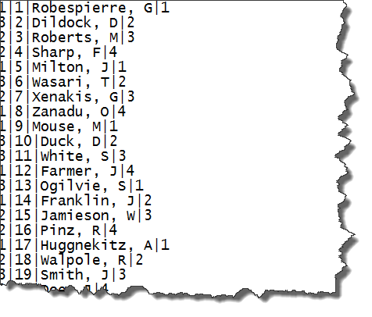

The sales for the week are contained in a file, which simply has an employee number and the sales amount. For each sale, an employee receives $5, regardless of the amount of the sale.

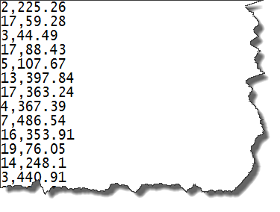

Your objective is to create a report resembling that below:

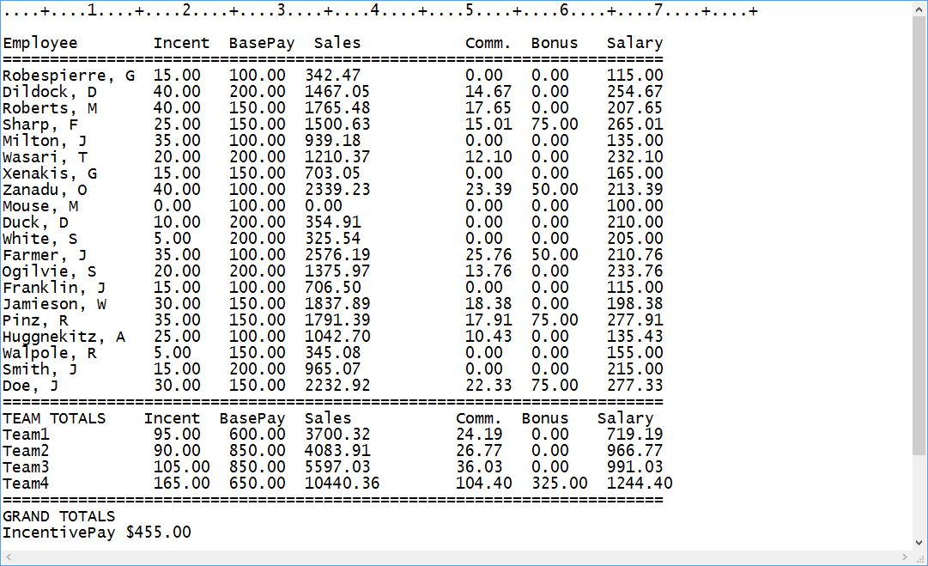

The INCENT column shows the total individual sales incentive (Walpole had 1 sale), the BasePay is based on the sales associate’s level, and the Sales column depicts the total amount of the sales for the sales associate.

Commission:

* Level 1: 1% of the associate’s sales
* Level 2: 2.25% of the associate’s sales
* Level 3: 3.5% of the associate’s sales

In addition, all associates belonging to the Team which sells the most (raw dollar amount) receives a bonus:

* Level 1: $50
* Level 2: $75
* Level 3: $100

Changes to the report above:

1. Alter the report to show amount (payments) as ‘right-aligned’ so that the decimal point lines up